***Gray bunny***

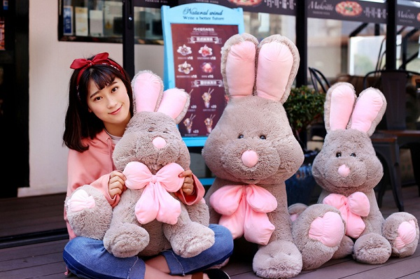

*Gray plush rabbit is made of high quality cotton, safe to use.  
Cute and funny design.  
Size length size 70cm.  
Gray plush bunny is suitable as a gift for a girlfriend or for children.*